A LANDSCAPE ANALYSIS OF NEONATAL NURSING EDUCATION
PROGRAMS IN AFRICA

A COLLABORATIVE EFFORT BETWEEN THE COUNCIL OF INTERNATIONAL NEONATAL NURSES (COINN) AND PROJECT HOPE

RESULTS REPORT

Prepared by Project HOPE and COINN GTAC Working Group
September 5, 2023

A LANDSCAPE ANALYSIS OF NEONATAL NURSING EDUCATION PROGRAMS IN AFRICA

CONTENTS
INTRODUCTION 3
SIGNIFICANCE 4
MISSION AND GOALS 4
METHODOLOGY 5
SURVEY RESULTS 6
ANALYSIS AND COMMENTS 8
SUMMARY and NEXT STEPS 9
RESOURCES 11

ANNEX
CONTACT LIST 12
SURVEY FORM 13

GLOSSARY:
BS.c Bachelor of Science Degree in Nursing
COINN Council of International Neonatal Nurses
CoP Community of Practice
CoNP Community of Neonatal Nursing Practice
GTAC Global Technical Advisory Group
LMIC Low-Middle Income Countries
MS.c Master of Science in Nursing
NNE Neonatal Nursing Education
SON School of Nursing
UNICEF United Nations-
WHO World Health Organization

INTRODUCTION
The Council of International Neonatal Nurses (COINN) and Project HOPE have collaborated on the development of a Landscape Analysis that attempts to examine the extent of specialized neonatal nursing education programs across Africa. This analysis is aligned with the WHO strategy 4: Create and train a new cadre of specialized neonatal nurses and examine the extent to which Neonatal Bachelor and Master degree programs are in existence or in development that aim to prepare this cadre in sub-Saharan Africa. With the establishment of the COINN Global Technical Advisory Committee (GTAC) and Community of Practice (CoP)-specifically the Community of Neonatal Nursing Practice (CoNP), funded by the Gates Foundation, it was recommended that GTAC, in collaboration with Project HOPE, provide an update and description on the existing neonatal nursing degrees as well as identification of developing programs in Africa. A previous analysis was initiated in 2021 by Project HOPE and COINN but was limited due to existing resources. The experience from this earlier analysis was helpful to meeting the challenges of the current more extensive analysis.
There is currently a limited standardization in education requirements for specialized degrees in nursing throughout the continent of Africa, which has led to differing advanced degree titles from country to country. Many advanced degrees are combined with other specialization such as pediatrics or midwifery, which has the potential to reduce the impact of solely neonatal specialized degrees. A robust evaluation of current advanced degree neonatal programs and health impacts would inform future education developments.

Programs focused on building the skills of nurses caring for newborns can happen at the pre-service, in-service, on-the-job, at the certificate level, and in advanced degree program specialization programs. This landscape analysis focuses on identifying Bachelor (B.Sc) and Master’s (M.Sc) Degree programs at the University level that have a specific specialization in neonatal nursing within the African region. The World Health Organization (WHO) recommends that Neonatal Nurse advanced or postgraduate programs be part of a nationally accredited education program, usually lasting between 2-3 years (WHO, 2020).

The Analysis is intended to inform the COINN Community of Neonatal Nursing Practice (CoNP) of the status of existing advanced neonatal nursing programs at the B.Sc and M.Sc levels across African countries that responded to the Landscape Survey. The Contact List will enable broader communications and opportunities for sharing expertise and experience. It is a working document that will need continued updating as well as more detailed knowledge about individual programs. Barriers to the establishment of advanced programs will be shared as well as opportunities to address the barriers and long- term sustainability. The data will assist the CoNP to promote collaboration between different stakeholders such as universities, ministries of health, global health organizations, professional organizations, and regulating bodies which is vital for sustainable education programs. This collaboration is also necessary to build adaptable curricula and scope of practice including faculty preparation and clinical preceptorship that meet global standards. The ultimate goal of expanding standardized and accredited neonatal nursing education, with local adaptability, is to strengthen neonatal nursing capacity to care for small and sick newborns.
SIGNIFICANCE
Globally, about half of all under-5 deaths happen during the neonatal period (UNICEF, 2020a). While Neonatal mortality trends downwards, it is often at a slower rate than under-five mortality (UNICEF, 2021). Neonatal Mortality rates are highest in sub-Saharan Africa, with neonates having ten times the risk of dying than in high-income countries (UNICEF, 2020b). There are many reasons for this disparity, one of them being access to quality healthcare (Gage et al., 2019). Healthcare access and quality of care both impact health outcomes. 61% of newborn deaths in the first 28 days are attributed to low-quality healthcare (UNICEF, 2020a). There is currently a gap in nursing care for small and sick newborns, as nurses provide much of the care for women and children, especially in regions with limited healthcare access. Caring for neonates requires advanced and specialized training. Advanced degrees with specialized training should therefore be created to increase capacity for newborn care. Creating long-term and sustainable improvement in neonatal morbidity and mortality, and subsequently child health, can be achieved with sustainable and long-term education programs in neonatal nursing. This requires upfront investment of time, money, and expertise to create and implement advanced degrees at the bachelor and master’s levels.

GOALS AND VISION
The WHO published the Roadmap on Human Resources Strategies in 2020 which highlights ten strategies to improve newborn care in health facilities in low- and middle-income countries (WHO, 2020). This landscape analysis aligns with Strategy 4: Create and train a new cadre of specialized neonatal nurses and examines the extent of such neonatal nursing bachelor and master degree programs that are in existence or in development that aim to prepare this cadre in sub-Saharan Africa.
COINN’S mission is “to strengthen and empower the neonatal nursing workforce via a sustainable global community of neonatal nursing practice (CoNP) that is committed to advancing education mentorship, research, advocacy, and leadership.” The Landscape Analysis supports this Mission by updating information on existing and developing advanced neonatal nursing education programs (NNE) for the purpose of networking, communication, and sharing information to support the COINN CoNP Goals:
- Create a sustainable community of practice to advance evidenced-based standardized education and quality family-centered care,
- Cultivate a cadre of professional neonatal nurses to develop and strengthen leadership and mentorship skills to obtain optimal neonatal health outcomes,
- Accelerate change in the development of the specialization of neonatal nursing, and
- Advocate for all newborns and their families especially the small and sick newborns
The Landscape Analysis collaborative process will provide updates with descriptions of B.Sc and M.Sc programs from stakeholders across Africa that responded to the Landscape Survey and will be shared widely among the network of neonatal nursing leaders.

METHODOLOGY
The purpose of the Neonatal Nursing Education Landscape Analysis project is to gather information on the status of neonatal nursing education programs at the advanced level in African countries. This analysis aligns with WHO Strategy to create and train a new cadre of specialized neonatal nurses and examined the extent to which Neonatal bachelor and master’s degree programs are in existence or in development that aim to prepare this cadre in Africa. The collaboration between COINN and Project HOPE enabled the human resources needed to develop the survey, initiate the research, provide repeated communications with contacts, and analysis by the GTAC Working Group.
The Landscape Analysis examines the extent of neonatal nursing B.Sc and M.Sc programs that are in existence or in development that aim to prepare this cadre in sub-Saraha Africa. Sources used in this process included online searches, published documents, knowledge from discussions with global network of professionals, and iterated conversations to inquire and validate information with various institutional and stakeholder contacts between June and September 2023. The global network of contacts included Ministries of Health, Professional Nursing Organizations, UNICEF, Schools of Nursing, Universities, global health organizations and regulating bodies.
The Landscape Analysis Survey Tool (See Annex 1): The Survey Tool was developed by the GTAC Working Group and focused on obtaining information on existing schools of nursing that offered a B.Sc and/or M.Sc program in advanced neonatal nursing in African countries. The Survey gathered information on key contacts, neonatal programs, curricula, length of program, number of graduates, and faculty preparation programs. Program standards, required number of clinical and theory hours, and skill competencies were also included on the survey. Many Ministries of Health have in-service (non-degree) neonatal certificate programs thus the survey included a question about these certificate programs. The survey also asked if the contacts would share their BS.c./MS.c. curricula with COINN.
The survey was disseminated in both in English and French, to target as many countries and schools as possible. A total of 43 surveys were sent out to key contacts. These contacts were sourced from existing COINN and Project HOPE relationships, online searches, and phone calls. Of the 43 surveys, 20 responses were received. Therefore, a total of 20 unique responses were collected, with a 46% response rate following several reminders. An initial email requesting contacts to fill out the survey was sent out on June 20, 2023 in both English and French, where appropriate. Several follow-up and reminder emails were sent, with the final reminder and request for response sent on in August 14, 2023.
Survey Challenges: The recipients of the survey typically requested validation of the sponsor and purpose of the survey which increased the number of required communications. Often, contacts needed to be reminded to fill out the survey and repeated survey forms needed to be sent. In some countries, contacts were difficult to obtain with long delays. Frequent requests from universities had to proceed through the management authorities to obtain the School of Nursing (SON) contacts. Some contacts did not have enough information to fill out important sections, others neglected to input critical information.

SURVEY RESULTS
Contacts Gained:
Of the 43 surveys sent, 20 respondents answered and spanned 10 countries across Africa. These countries are South Africa, Sierra Leone, Lesotho, Swaziland, Rwanda, Kenya, Zambia, Zimbabwe, Malawi, and Ethiopia. Through this survey, we received 21 contacts who are active in neonatal education and included research directors to practicing nurses and deans of neonatal nursing schools.

Contacts: Bachelors and Masters Level Degrees in Neonatal Nursing (2023)
Program | B.Sc. Programs | M.Sc. Programs | Awaiting State Approval | Schools Offering Certificate Programs in Neonatal Nursing
Number | 3 | 5 | 1 | 2
Locations | Sierra Leone, Kenya, Malawi | Rwanda, Zambia, Lesotho, Ethiopia,  Sierra Leone | South Africa- (BS.c) | Zambia, Rwanda, Ghana

In the institutions surveyed, only three, in Sierra Leone, Kenya and Malawi, currently offer B.Sc. neonatal nursing degrees. Several BS.c programs offer combined degrees which typically include midwifery or pediatrics, as in Lesotho, Sierra Leone, and South Africa. There are five established M.Sc. degree programs in neonatal nursing according to the survey. Of the eight established and existing B.Sc. and M.Sc. neonatal nursing degree programs, five cite using WHO standards for curriculum development, most require clinical hours at a level 3 referral hospital and use national standards to guide curriculum, and two use the COINN curriculum.

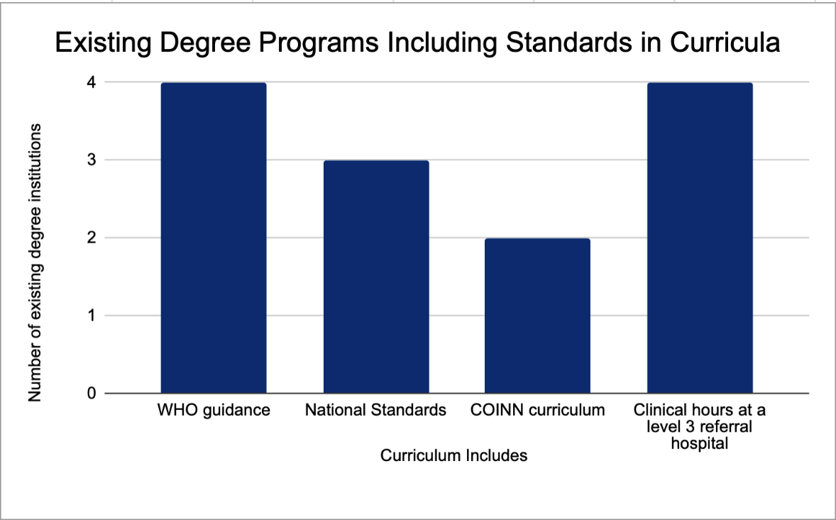
Three of the five institutions that currently have M.Sc. degrees in neonatal nursing cited visiting faculty members from universities in the United States. Each program is two years in length. The B.Sc. degree programs in Sierra Leone and Malawi indicated that their degree is two years long.
When asked about barriers to advancing neonatal nursing education in their countries, many cited a shortage of resources such as qualified faculty and trained clinicians. Some indicated that their nation’s health priorities did not include neonatal nursing. Others indicated that general nursing courses or ones focused on maternal health included only a small number of units in neonatal training. One respondent mentioned a shortage of career paths post-graduation.
In Lesotho, Rwanda, Malawi, and Zambia, the Nursing and Midwifery Councils recognize the Neonatal Nursing Programs and their graduates. However, only Rwanda and Sierra Leone indicated their Ministry of Health recognize the advanced degree and provide jobs for graduates.

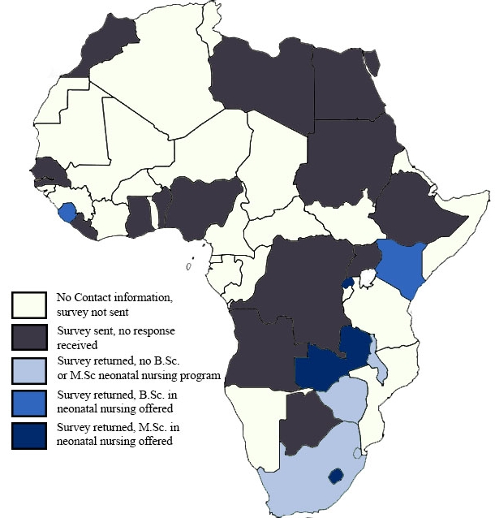

ANALYSIS AND COMMENTS
There is an increase in the development of advanced neonatal nursing programs on the African continent. The survey focused on the existence of B.Sc and M.Sc neonatal nursing programs and included those institutions that are in the development stage. There is a recognition that standards are needed in the development of curricula and some countries include WHO, COINN and national standards. It seems connections between countries are not very active and sharing of experiences is minimal so efforts by COINN, HOPE and others to facilitate these connections is important. Encouraging south-south communications will also be important to finding local talent to support the advancement of neonatal care programs as well as international support.
This Landscape Survey (2023) is a survey to locate the current existence of advanced neonatal nursing programs in African countries. However, in 2021, Project HOPE and COINN conducted a landscape analysis to assess where current programming in neonatal nursing existed in sub-Saharan Africa. The 2021 landscape analysis relied on desk research and provided a snapshot of existing and developing programming in neonatal nursing in sub-Saharan Africa. Through that landscape analysis, three B.Sc. and three M.Sc. programs were identified in Ethiopia, Malawi, Sierra Leone, Rwanda, and Zimbabwe. The 2021 report also indicated the development of two other neonatal master’s programs in South Africa and Tanzania. Comparing the August 2023 results to the previous landscape analysis in 2021 indicates that this current survey is missing data on Ethiopia (they have pre-existing B,Sc and M.Sc. program) and Zimbadwe and indicates that the developing programs in South Africa and Tanzania have not yet been established. None of the respondents agreed to share their curriculum.
There was a diligent effort to follow all leads to country institutions and their status of developing neonatal nursing programs. With the assistance from regional UNICEF directors, the Contact List was extended. Several institutions did not feel comfortable filling out the survey form unless senior management of their institution was comfortable with it, and some did not answer all of the questions on the survey form. So there is a definite need to re-visit the current list of programs and continue to contact the remaining countries through direct communications. The survey will therefore remain active for any future new contacts to meet the goal of a comprehensive contact list through tracking new referrals.
The Contact List does not include short-term training programs such as in-service and certificate programs but they exist and these countries might be ready for development of advanced degree programs. The development of neonatal care short-term courses often increases the awareness of the need to offer advanced specialized programs to meet the complex needs of small and sick newborns.
Barriers to the development of advanced neonatal programs were identified in some returned surveys. Lack of financial resources and qualified faculty and clinical experts were the most common. Other barriers included the lack of career paths and incentives. Several mention that the National Health Strategy for Human Resources did not include the specialty of neonatal nursing. These barriers should be addressed by the COP including creative ways to overcome them.
Key Take Aways:
- There is increasing awareness of the need to develop B.Sc and M.Sc neonatal nursing programs but limited cross-country planning, sharing of experience, and standardization.
- Most established programs use an irregular combination of international and national standards to guide neonatal education and practice so there is a mix of standards across programs and countries.
- There are limited faculty training programs to build faculty capacity to teach theory in advanced neonatal education and substantial assistance is needed to prepare them to teach in clinical settings.
- There is a lack of communication channels between international and national professional organizations and the developing advanced neonatal education programs.
- It is difficult to gather information from low-middle income countries (LMIC) and politically unstable countries and more effort is needed to include these countries in the Contact List.
- Because of the limited cross-country communications, the CoP needs to develop ways of sharing information, curricula, training, and evaluation materials both for faculty and their administrations.
- Advocacy for advanced neonatal nursing programs remains critical since ministries and universities do not have the personnel and materials resources to develop new programs. It is more cost effective for Ministries of Health to have shorter certificate in-service programs than the development of higher education advanced programs. The development of a new cadre of neonatal nurses will provide additional health workers for newborns and will be more sustainable.
- An on-going Landscape Analysis process is needed to enable frequent follow- up and to include the countries who did not respond.
- A process for addressing barriers to the development and sustainability of advanced neonatal nursing programs is needed for there are common problems such as the availability of qualified faculty and clinical experts.

SUMMARY AND NEXT STEPS
A continued robust evaluation of current advanced degree neonatal programs and health impacts is needed to inform future education developments. There is currently a limited standardization in education requirements for specialized degrees in nursing throughout the continent of Africa, which can lead to differing advanced degree titles from country to country. Many advanced degrees are combined with other specializations such as pediatrics or midwifery, which has the potential to reduce the impact of solely neonatal specialized degrees.

As such, this Landscape Analysis is a snapshot in time and will evolve with the addition of more neonatal nursing programs and could be seen as the first in a series of updates that can include not only African countries but also other geographic regions throughout the globe. There is also a need to validate some of the information provided such program length. The COINN GTAC Working Group considers this a working document and will continue to gather, validate, and update the Contact List including accurate descriptions and details of B.Sc and M.Sc neonatal nursing programs from all known stakeholders and collaborators in Africa.

LIST OF RESOURCES
Bruce, J.C., Schmollgruber, S., Baumann, J. (2018). Intercountry master's degree in nursing: policy implications for the Mozambican health system. International Nursing Review. 65(3): 425-433.
Gage, A.D., Carnes, F., Blossom, J., Aluvaala, J., Amatya, A., Mahat, K., Malata, A., Roder-DeWan, S., Twum-Danso, N., Yahya, T., Kruk, M.E. (September 2019). In Low- And Middle-Income Countries, Is Delivery In High-Quality Obstetric Facilities Geographically Feasible? Health Affairs 38:(9) https://doi.org/10.1377/hlthaff.2018.05397
UNICEF. (July 2020a). Ending preventable newborn deaths and stillbirths by 2030. https://data.unicef.org/resources/ending-preventable-newborn-deaths-and-stillbirths-by-2030/
UNICEF. (September 2020b). Neonatal mortality. https://data.unicef.org/topic/child-survival/neonatal-mortality/
UNICEF. (December 2021). Under-Five Mortality.
University of Zimbabwe. Medicine And Health Sciences Programmes. (n.d.) https://www.uz.ac.zw/index.php/chs-programmes
WHO. (2020). Human resource strategies to improve newborn care in health facilities in low- and middle-income countries. World Health Organization.

ANNEX 1
CONTACT LIST
Country | University | Respondent | Contact information
South Africa | North-West University Nursing and Midwifery Research Director | Welma Lubbe | welma.lubbe@nwu.ac.za
Zimbabwe | Bindura School of Nursing and Midwifery | Jenifa Chikwadze | jchikwadze@gmail.com
Zambia | Master of Science in Neonatal Nursing | Patricia Katowa-Mukwato | mukwato.patricia@unza.zm
Zambia | Cavendish University Zambia | Christine M Mutati | christinemutati@gmail.com
Zambia | Lusaka College of Nursing and midwifery | Eric Chisupa | ericchisupa@yahoo.com
Zambia | Lusaka College of Nursing and Midwifery | Yona Mofu | mumbaymofu@gmail.com
Malawi | School of Maternal, Neonatal and Reproductive Health Services | Elizabeth Chodzaza | echodzaza@kuhes.ac.mw
Kenya | Masinde Muliro University Kakamega | Zipler Imbuye | zilperimbuye@gmail.com
Eswatini-Swaziland | UNESWA (University of Eswatini Faculty of Health Sciences) | Sakhile Masuku | sksmasuku@gmail.com
Kenya |  | Alice Christine Awuor | christinawuor@yahoo.com
Lesotho | MNS Midwifery and Neonatal Nursing | Maelinyane | tpmaselinyane@gmail.com, mothissy@gmail.com
Rwanda | School of Nursing and Midwifery | Philomene Uwimana | p.uwimana1@ur.ac.rw, philouwim@gmail.com
Sierra Leone | College of Medicine and Health Sciences (COMAHS) | Joseph Edem-Hotah | jedemhotah@yahoo.com
South Africa | North-West University Nursing and Midwifery Research Director | Dr Molekodi Matsipane | Molekodi.matsipane@nwu.ac.za
Zambia | Cavendish university Zambia | Florence Myzece | fmyzece@cavendish.co.zm
Zambia | Lusaka college of nursing and midwifery | Dr Priscar Mukonka | priscarmukonka@yahoo.com
Kenya | Musinde Muliro University Kakamega | John Arudo | Johnarudo@mmst.or.ke
Lesotho | MNS Midwifery School | Ntsoaki Ralejoana | ntsoaki.ralejoana@yahoo.com
Ethiopia | SPHMMC | Asrat Demtse  Redeat Workneh | asratdg@yahoo.com  redugold@gmail.com
Ghana | School of Nursing and Midwifery | Hannah Acquah | Acquah.h@genm.edu.gh

ANNEX 2: LANDSCAPE SURVEY FORM

NEONATAL NURSING EDUCATION PROGRAMS: AFRICAN COUNTRIES LANDSCAPE ANALYSIS SURVEY
This Landscape Analysis Survey will assist the COINN Global Technical Advisory Committee (GTAC) and Project HOPE to better understand the development of neonatal advanced nursing education programs in African countries. It will also determine how Project HOPE and COINN can assist the development of programs and standards and promote the sharing of program materials and experiences that may be helpful to the advancement of neonatal education.

COUNTRY: _______________________________
CONTACT INFORMATION (person filling out form):
NAME and TITLE: _____________________________________________________________
PROGRAM AFFILIATION: ________________________________________________________
E-MAIL: ______________________________________________________________________
NAME OF UNIVERSITY: _________________________________________
NAME OF SCHOOL OF NURSING: _________________________________
CONTACT INFORMATION: SCHOOL OF NURSING DIRECTOR
NAME: ______________________________________________
E-MAIL: _______________________________________________

NEONATAL PROGRAM INFORMATION
Do you offer an advanced degree in Neonatal Nursing? (Check)
B.Sc. ____
M.Sc. ____
If you offer a B.Sc. Neonatal Nursing Program, please fill out the following information.
Title of Program: _____________________________
Length of Program: __________________
Admission Criteria: ________________________________________________
Number of Graduates: _______________
Number of Faculty: __________________
Curriculum includes:
National Standards? _________
COINN? __________
WHO? _______________
Other? __________
If other, please describe: ________________
Number of Theory Hours: ____________
Number of Clinical Hours: ____________
What type of setting are your clinical hours completed in? (select one)
Level 1 (small hospital or health center)
Level 2 (district or provincial hospital)
Level 3 (referral hospital)
Do you have an external organization contributing faculty, mentorship, or program support?
Yes (describe): _______________________________________________
No: ______
Is the B.Sc. Neonatal Program offered as a separate or combined degree? (i.e. Neonatal-Pediatrics?)
Separate Degree ____
Combined Degree ____
If a combined degree is offered, describe: _____________________________

If you offer a M.Sc. Neonatal Nursing Program, please fill out the following information.
Title of Program: _____________________________
Length of Program: _________________
Admission Criteria: ________________________________________________
Number of Graduates: _______________
Number of Faculty: _______________
Curriculum includes:
National Standards? _________
COINN? __________
WHO? _______________
OTHER? ________________
If other, describe: _____________________________________________
Number of Theory Hours: ____________
Number of Clinical Hours: ____________
What type of setting are your clinical hours completed in? (Select one)
Level 1 (small hospital or health center)
Level 2 (district or provincial hospital)
Level 3 (referral hospital)
Do you have an external organization contributing faculty, mentorship, or program support?
Yes (explain): ________________________________________________
No: _____
Contact Information for program head (If different from above):
________________________________________________________________________
Is the M.Sc. Neonatal Program offered as a separate or combined degree? (i.e. Neonatal-Pediatrics?)
Separate Degree ____
Combined Degree ____
If a combined degree is offered, describe: _____________________________

Would you be willing to share your B.Sc. and or M.Sc. Curriculum with COINN? (If yes, please upload)
___________________________________________________________________________________
Does the Ministry of Health or your hospital affiliation offer neonatal in-service or certificate programs for basic or practicing nurses? If so, please describe.
___________________________________________________________________________________
Short In-service Courses: _________________________________________________________
Certificate Courses: _____________________________________________________________
Is there a designated national scope of practice for neonatal specialty nurses?
Yes: ____
No: ____
Is there an established scheme of service for neonatal specialty nurses?
Yes: ____
No: ____
Does the Ministry of Health recognize the advanced Neonatal Nursing Degree(s) and provide jobs for graduates? Yes: ______ No: ______
Do the Nursing and Midwifery Councils recognize the Neonatal Nursing Programs and their graduates? Yes: _____ No: ______
What are the barriers to advancing neonatal nursing education in your country?
______________________________________________________________________________
Other Comments:
___________________________________________________________________________________

COINN-GTAC and Project HOPE WILL SHARE RESULTS OF THE SURVEY WITH YOU.
THANK YOU.

